Signals and Systems (CT 203)

Tutorial Sheet-02 DA-IICT, Gandhinagar.

- For the following signals verify if they are of energy/power type. Accordingly compute the energy and power of the signal over a duration of T seconds

- 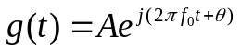
- 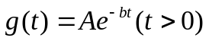
- 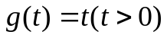
- 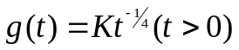

- Let 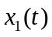 and 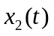 are periodic signals with fundamental periods and 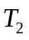 respectively. Under what condition is the sum 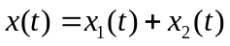 is periodic, and what is the fundamental period of  if it is periodic? Is 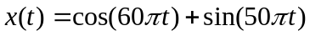 periodic? If yes find fundamental time period.

- Determine the values of 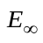and 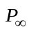 for each of the following signals
(a) 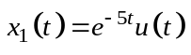 (b) 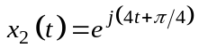
(c) 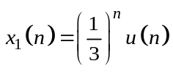

- A continuous-time signal 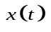is shown in Fig. 1. Sketch and label carefully each of the following signals:
(a) 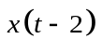 (b) 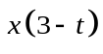
(c) 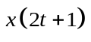 (d) 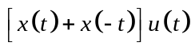

0
1
2
-1
-2
1
2
-1
Fig. 1. A continuous-time signal
t
- A discrete-time signal 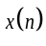is shown in Fig. 2. Sketch and label carefully each of the following signals:
(a) 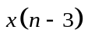 (b) 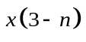
(c) 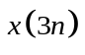 (d) 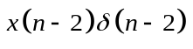
-1
0
2
4
-2
-4
1
Fig. 2. A discrete-time signal
n
1
3
-1
-3
-1/2
5
-5
1/2
1/2

- Determine whether each of the following signals is periodic
(a) 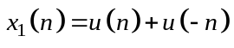 (b) 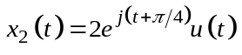
(c) 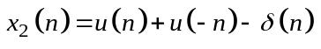 (d) 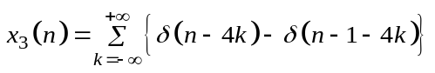

- Check whether the following results holds
(a) 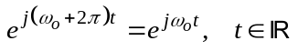 (b) 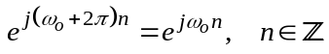

Is there any conclusion from the solution of above problem in the context of periodicity of continuous time vs. discrete time complex exponential signal?

- Prove that complex exponential signal, i.e., 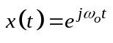has infinite total energy but finite average power.

